**10.1 The Excretory System\***

* Regulation of blood pressure, blood osmolarity, acid-base balance, and removal of nitrogenous wastes

Anatomy of the Excretory System

* Kidney produces urine, which dumps into ureter at the **renal pelvis**
* Urine is then collected in the bladder until it is excreted through the urethra
* The kidney has a cortex and medulla. Each kidney has a hilum, which contains a renal artery, renal vein and ureter
* Renal portal system
  + Blood from the renal artery flows into **afferent arterioles**, which form glomerulus in Bowman’s capsule (the first capillary bed)
  + Blood then flows through the **efferent arteriole** to the **vasa recta**, which surround the nephron (the second capillary bed), before leaving the kidney through the renal vein
* Bladder structure
  + Has a muscular lining called detrusor muscle, which is under parasympathetic control
    - Bladder is full → stretch receptors activated → parasympathetic neurons fire → detrusor muscle contracts → internal sphincter relax (i.e. micturition reflex) → up to individual to relax external sphincter to urinate
  + Has two muscular sphincters
    - **Internal urethral sphincter**
      * Consists of smooth muscle and is under involuntary (parasympathetic) control
    - **External urethral sphincter**
      * Consists of skeletal muscle and is under voluntary control

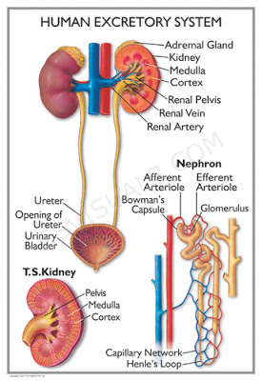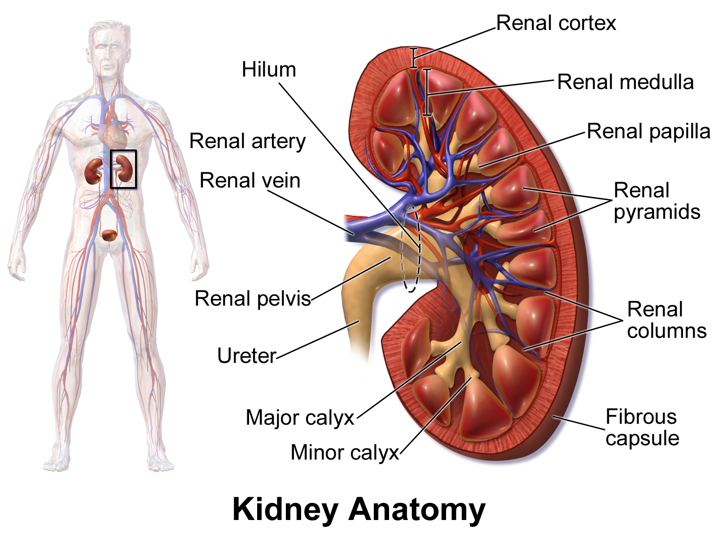

Osmoregulation

1. Filtration → movement of solutes from **blood to filtrate at Bowman’s capsule**
   1. Higher hydrostatic pressure in the glomerulus (forces blood out) >> Higher oncotic pressure due to high blood osmolarity in the glomerulus (draws blood back) → netflow is still from blood into the nephron (glomerulus → Bowman’s capsule)
   2. Large size molecules cannot pass through glomerulus
2. Secretion → movement of solutes from **blood to filtrate** anywhere **besides** Bowman’s capsule
   1. Secretion of salts, acids, bases and urea directly into the tubule by either active or passive transport
3. Reabsorption → movement of solutes from **filtrate to blood**
   1. E.g. glucose, amino acids, vitamins
   2. Quantity of water reabsorbed can be affected by ADH and aldosterone

Nephron Function

* Dump the **HUNK** (**H**+, **U**rea, **N**H3, **K**+)

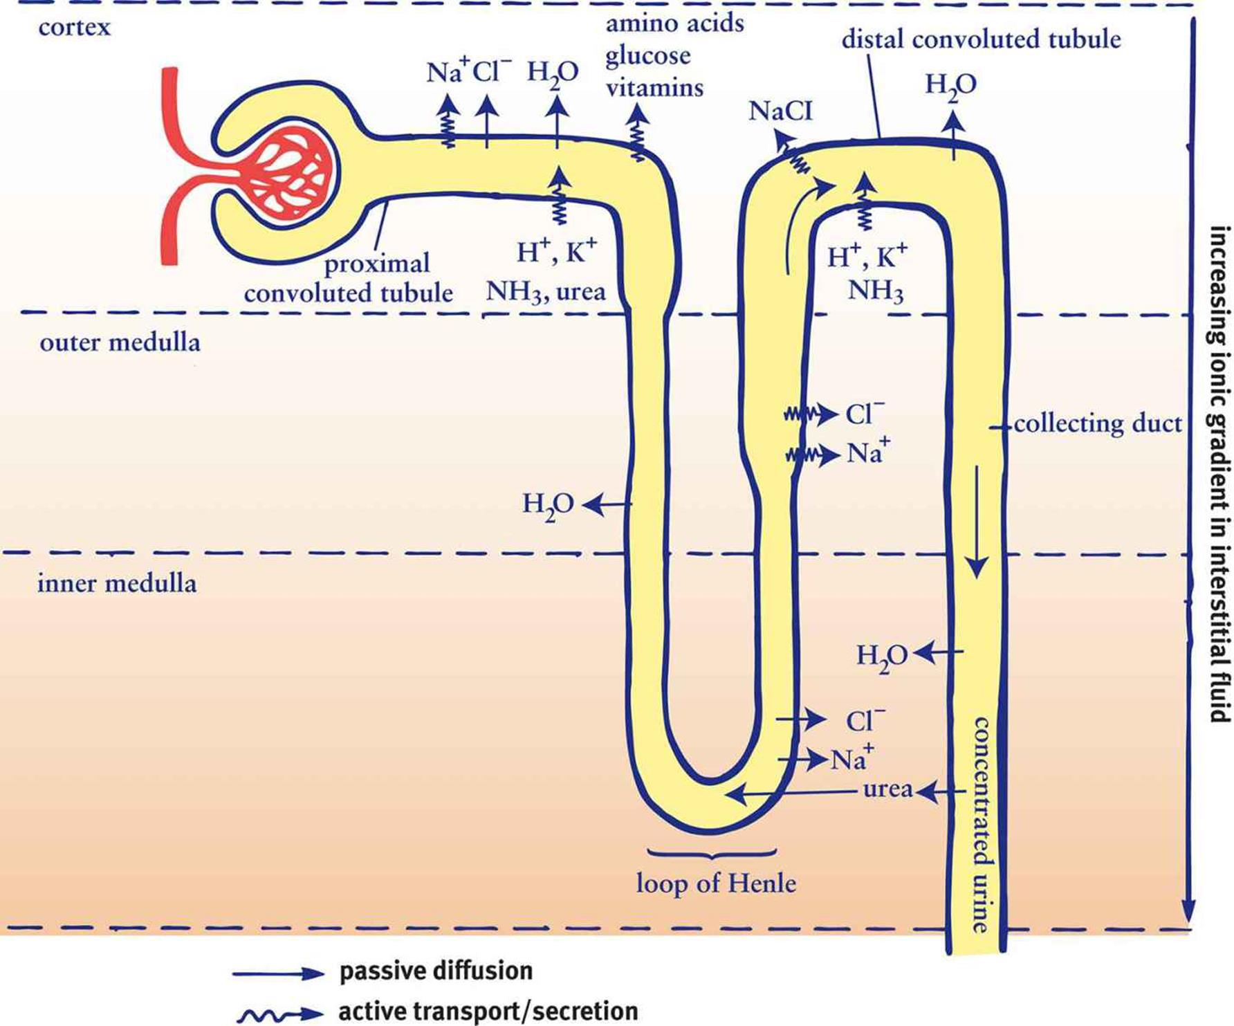

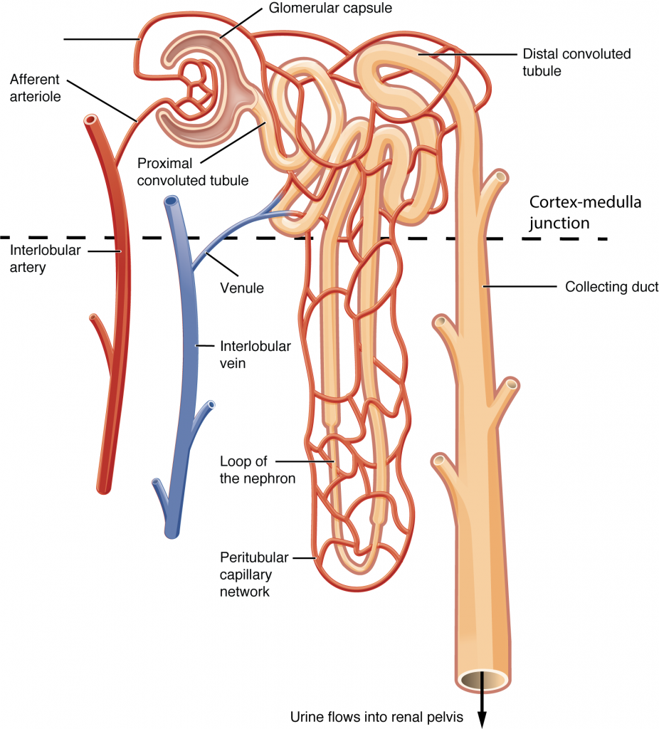

1. Proximal Convoluted Tubule (PCT)
   1. Site of bulk reabsorption of glucose, amino acids, soluble vitamins, salt and water
   2. Site of secretion for HUNK
2. Descending limb of the loop of Henle
   1. Permeable to water, but not salt → as filtrate moves into the more osmotically concentrated renal medulla, water is reabsorbed
   2. Vasa recta and nephron flow in opposite directions → countercurrent multiplier → maximum reabsorption of water
3. Ascending limb of the loop of Henle
   1. Permeable to salt, but not water → salt is reabsorbed passively (in the inner medulla) and actively (in the outer medulla)
   2. Note that the diluting segment is in the outer medulla → in fact, the filtrate becomes hypotonic compared to the blood.
4. Distal Convoluted Tubule (DCT)
   1. Responsive to aldosterone (water follows salt reabsorption)
   2. Site of salt reabsorption and waste production excretion
5. Collecting Duct
   1. Responsive to both aldosterone (water follows salt reabsorption) and ADH (only water reabsorption)
   2. Variable permeability depending on body’s needs

Functions of the Excretory System

* Regulate blood pressure and blood osmolarity
  + ADH only governs water reabsorption
    - Increase blood volume and pressure
    - Lower blood osmolarity
  + Aldosterone causes both salt and water reabsorption
    - Increase blood volume and pressure
    - Does not change blood osmolarity
* Acid-base balance (using bicarbonate buffer system)
  + When blood pH is too low
    - Excrete more H+
    - Increase reabsorption of bicarbonate
  + When blood pH is too high
    - Excrete more bicarbonate
    - Increase reabsorption of H+
  + Slower than respiratory response, but also highly effective

**10.2 Skin**

* Contains hypodermis (subcutaneous layer), dermis, and epidermis

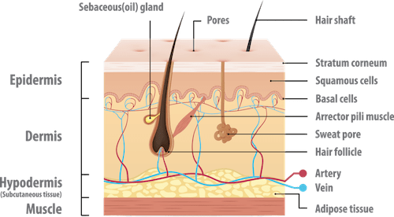

Structure

1. Epidermis (from superficial to deep: **C**ome, **L**et’s **G**et **S**un **B**urned)
   1. Stratum **b**asale
      1. **Contains stem cells** → proliferation of keratinocytes (predominant cells of the skin that produce keratin)
   2. Stratum **s**pinosum
      1. **Site of Langerhans cells** → special macrophages that are antigen-presenting cells to T-cells
   3. Stratum **g**ranulosum
      1. Keratinolocytes die and lose their nuclei
   4. Stratum **l**ucidum
      1. Present in thick, hairless skin e.g. skin on the sole of the foot or the palms; nearly transparent
   5. Stratum **c**orneum
      1. Many layers of flattened keratinocytes → barrier against pathogens + prevent fluid loss
2. Other cells of the Epidermis
   1. Calluses
      1. Form from excessive keratin deposition in areas of repeated strain due to friction → avoid damage in the future
   2. Fingernails and hair
      1. Formed from keratin
   3. Melanocytes
      1. Cell type derived from neural crest cells and found in the stratum basale
      2. Produce melanin (a pigment that protects skin from DNA damage caused by UV radiation) → later passed to keratinocytes
      3. More melanin → darker skin tones
   4. Langerhans cells
      1. Macrophages within the stratum spinosum
3. Dermis
   1. Consists of two layers: papillary layer (loose connective tissue right below the epidermis) and denser reticular layer
   2. Sweat glands, blood vessels, and hair follicles originate in the dermis
   3. Sensory receptors
      1. Merkel cells (discs) → connected to sensory neurons and are responsible for deep pressure and texture sensation within the skin
   4. Sensory organs
      1. Free nerve endings → respond to pain
      2. Meissner’s corpuscles → respond to light touch
      3. Ruffini endings → respond to stretch
      4. Pacinian corpuscles → respond to deep pressure and vibration
4. Hypodermis
   1. Layer of connective tissue that connects the skin to the rest of the body
   2. Contains fat and fibrous tissue

Thermoregulation

* Cooling mechanism
  + Sweating absorbs heat from the body through evaporation of water from sweat (sweat glands are innervated by postganglionic cholinergic sympathetic neurons)
  + Vasodilation brings more blood to the skin to accelerate heat loss
* Warming mechanism
  + Piloerection: arrector pili muscles contract → hairs stand on end → trap a layer of warmed air around the skin
  + Vasoconstriction, shivering, insulation provided by fat